Brief note on installation of Display board at DEOC Kailali
Background
Three display boards have also been installed at DEOC with the financial, equipment and technical support from SAFER-Nepal Project a project of Mercy Corps Nepal. The boards show the water levels of Karnali at Chisapani, Mohana at Malakheti and rainfall level of Bhaktapur, Nigali. The people of downstream communities of Phulbari, Pawera, Ratanpur, Lalbojhi, Dhansinghpur, Narayanpur, Tikapur, Durgauli, Sahajpur and Nigali will be benefited by the display boards. Siren used in the system will help alerting the DEOC staffs and nearby people as the water level reaches the warning or danger level. The river level at Chisapani and rainfall level at Bhaktapur, Nigali is displayed automatically since there are telemetric systems at Chisapani and Bhaktapur where as the river level of Mohana at Malakheti are displayed manually i.e; for Mohana, the board displays river level only after the gauge reader at Malakheti messages the river level to the sim cards used in the system. The automatic telemetric system (tipping bucket) was installed at Bhaktapur, Nigali VDC in 2012 with the support from Strengthening Capacity of communities for Disaster Risk Reduction through Early Warning in Nepal (SCORE-Nepal) project funded by DIPECHO VI and implemented by Mercy Corps Nepal and NRCS Kailali.
Objectives of the DEOC display board:
The broad objective DEOC display board is to reduce the losses due to disaster by strengthening the Flood Early Warning System of Kailali District where as the specific objectives is as follows:
- To show the real time water level of Karnali at Chisapani Station.
- To show the real time rainfall information of Station at Bhaktapur, Nigali.
- To show the water level of Mohana at Malakheti.
- To alert the DEOC staffs from security forces as the water level reaches warning or danger level with the help of siren that blows automatically as the water level reaches warning or danger level.
- To inform CDO, LDO, District Police Chief, NRCS president with the help of automatic SMS sent to them by the system as the river level of Karnali (Chisapani) and Mohana (Malakheti) reaches warning or danger level.

Strategy of the display boards:
The display boards installed at DEOC Kailali is intended to develop and strengthen linkages among community, VDCs, District and National level stakeholders. It shows the river level of Karnali at Chisapani, Mohana at Malakheti and rainfall level at Bhaktapur of Nigali VDC. As the river level reaches to warning or danger level, the staffs at DEOC verify the water level with respective gauge readers and DHM field office Attariya and immediately inform the local and district level security forces, REOC & NEOC (if required), media, NRCS District Chapters and Sub-Chapters and representatives (EWS task force members, VDC Secretaries or Ward Citizen Forum’s representatives) of vulnerable communities and VDCs using HF and UHF radios, telephone, mobiles and/or VOICENT software after verification. The DEOC Kailali has also been equipped with Computer system with VOICENT software and new telephone set/number. The VOICENT software sends automatic telephone calls to the list of telephone numbers entered in the system through which the pre recorded voice are delivered to the receivers. Hence, the information of river levels are first recorded once the DEOC gets flood early information and then sent to receivers through VOICENT Software once the information is verified. The numbers of some chosen people of vulnerable communities, media representatives, security forces etc. along the catchment of different river and their tributaries have been entered.
As the information is disseminated, the security forces and EWS task force members (if the task force has been formed) also alert the vulnerable communities and VDCs using hand mikes and sirens and the vulnerable people are shifted to safe place. In this way, the display boards’ support in coordinated response and helps to disseminate the Flood Early Warning Information to the vulnerable communities before the flood actually reaches the communities. Similarly, the automatic siren used in the system which blows as the rainfall and river level reach the warning or danger level, helps to alert the staffs at DEOC even though they are asleep or some 500 meters away from the display board location area. On the other hand, automatic SMS will be sent to CDO, LDO, District Police Chief and NRCS President as the river level reaches warning or danger level.
Expected outcome:
- It is expected that the response capacity of the district and vulnerable communities and VDCs will be increased.
- The lead and lag time will be increased. Hence the community will get the flood information earlier.
- Since the DEOC takes the lead in information dissemination and it is equipped with multiple communication devices like HF radio, UHF radio, VOICENT software, landline phone etc., the limitation due to poor or busy mobile networks will be overcome.
- It will be easier to seek regional or central support during major disasters since DEOC is linked with REOC and NEOC.
- It is expected that the human and property losses will be minimized by increased effectiveness of the Community Based Flood EWS of Kailali.

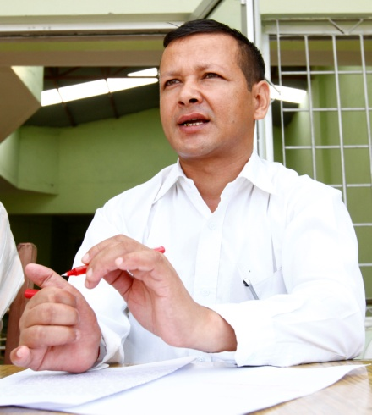
“The display boards at DEOC have increased the response capacity of Kailali District. Now we can observe the river level of Karnali (Chisapani) and Mohana (Malakheti) from the DEOC (District Administration Office) building and alert the district and local security forces and community during the situations when the flood level is rising rapidly and about to cross the warning and danger level. Since, the automatic siren also blows and automatic SMS is sent to CDO, LDO, NRCS President and District Police Chief as the river level of Karnali and Mohana crosses the warning and danger level or the rainfall of Nigali VDC which is in the hills of Kailali is more than 40 mm per hour and the rainfall still is continuing, it helps to alert the DEOC staffs even during night (even if they are asleep) and the DEOC staffs disseminate the flood messages to REOC, NEOC, local and district security forces, communities at risk and Humanitarian workers using different communication devices available at DEOC to help the vulnerable communities move to safe place before the flood affects the communities.” Says Chiranjivi Ghimire, Administrative Officer, District Administration Office Kailali.
Figure 1: Chiranjivi Ghimire, Administrative Officer, District Administration Office , Kailali
He further adds, “The District Administration Office and DEOC used to get flood information only after the local security forces asked for help during and after flood affects the communities and the disaster management was more focused on response only but after the linkage with Community Based Early Warning System and installation of Display board showing the river levels of Karnali and Mohana at DEOC, the situation has reversed. Now, the DEOC can alert the local security and communities at risk before the flood actually reaches the community. Similarly, the use of VOICENT software along with HF and VHF sets for dissemination of flood early warnings to communities and humanitarian workers has increased the efficiency of DEOC in disseminating Flood Information. I am confident that whatever the intensity of flood be the casualties and property losses will definitely be minimized in the upcoming years.”


“VOICENT system is a system that consists of Server with software (VOICENT) for broadcasting by Phone and Telephone line with internet connection. A server with VOICENT Software and internet connection has been made available at DEOC. DEOC gets the rainfall and flood information from DHM and community based gauge readers, district and local security forces as well as the display boards installed at DEOC. Once the information is verified, the DEOC staffs record the flood information in computer and at the push of a button on computer, the recorded voice messages are transmitted to a list of phone numbers saved on the server (Computer). The voice messages are more effective than text messages since even the illiterate people can get benefitted from the voice messages. As soon as they receive voice messages on their phones, they will use megaphones, sirens and warning flags to alert rest of the community. Besides disseminating flood information, this software is also being used in awareness raising activities. The proper use of VOICENT software will not only help in disseminating flood and rainfall information to vulnerable communities in an efficient, effective, reliable and equitable way but also in increasing the relationship between government (District Disaster Relief Committee) and vulnerable communities.”
Figure 2: Ramesh Shrestha, EWS Officer, Mercy Corps Nepal
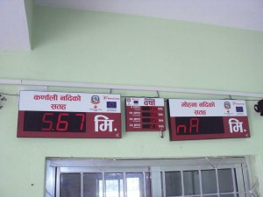
Display boards at DEOC Kailali showing the water level of Karnali at Chisapani and Mohana at Malakheti as well as rainfall at Nigali VDC of Kailali.

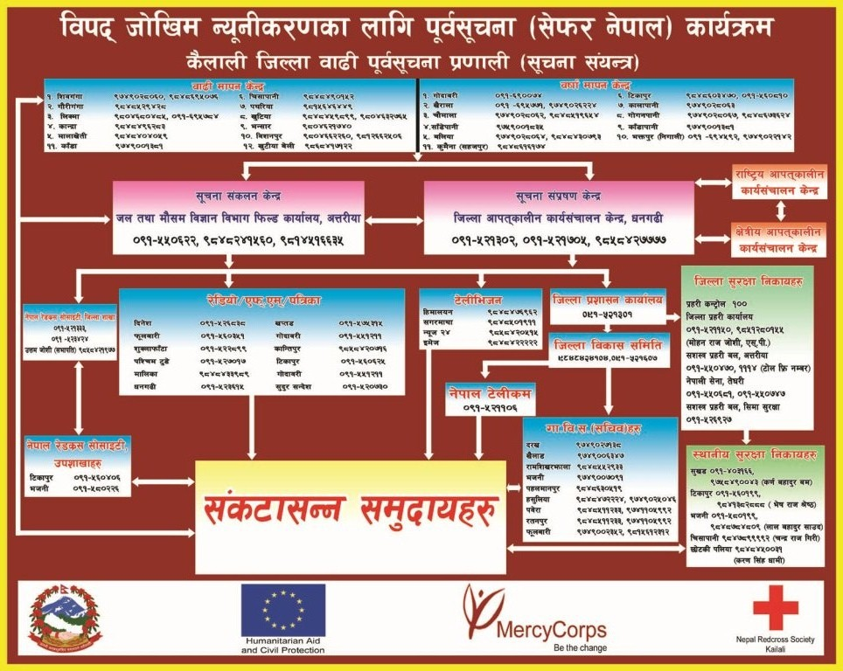
Communication channel for District Flood Early Warning System, Kailali.

